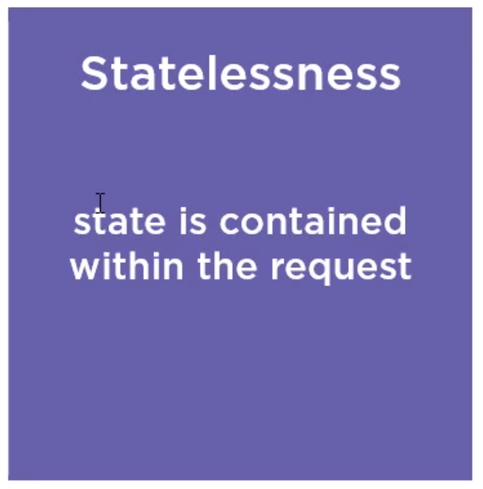

The third constraint is statelessness. This means that the necessary state to handle every request is contained within the request itself.

State is thus not kept on the server, but on the client, and when a client requests a resource, that request contains all the information necessary to service the request.

If we look back at one of our demo requests, this means that the combination of URI, headers, and potentially a body is sufficient for the API to fully handle the request.

This is one of the constrains that ensures RESTful APIs can scale so easily. As the state to handle the request is contained in the request itself, we don't have things like server-level session state to keep in mind when scaling up.